concrete_data

Shiva Sankar Modala

2023-03-01

#install.packages("tidyverse")

# readxl packages to load Excel data  
#install.packages("readxl")  
#install.packages("magrittr")  
#install.packages("corrplot")

# Use the mgcv package to create a generalized additive model  
#install.packages("mgcv")

# Visualize the regression using the visreg package,  
#install.packages("visreg")

library(tidyverse)

## ── Attaching core tidyverse packages ──────────────────────── tidyverse 2.0.0 ──  
## ✔ dplyr 1.1.0 ✔ readr 2.1.4  
## ✔ forcats 1.0.0 ✔ stringr 1.5.0  
## ✔ ggplot2 3.4.1 ✔ tibble 3.1.8  
## ✔ lubridate 1.9.2 ✔ tidyr 1.3.0  
## ✔ purrr 1.0.1   
## ── Conflicts ────────────────────────────────────────── tidyverse_conflicts() ──  
## ✖ dplyr::filter() masks stats::filter()  
## ✖ dplyr::lag() masks stats::lag()  
## ℹ Use the ]8;;http://conflicted.r-lib.org/conflicted package]8;; to force all conflicts to become errors

library(readxl)  
library(magrittr)

##   
## Attaching package: 'magrittr'  
##   
## The following object is masked from 'package:purrr':  
##   
## set_names  
##   
## The following object is masked from 'package:tidyr':  
##   
## extract

library(corrplot)

## corrplot 0.92 loaded

library(mgcv)

## Loading required package: nlme  
##   
## Attaching package: 'nlme'  
##   
## The following object is masked from 'package:dplyr':  
##   
## collapse  
##   
## This is mgcv 1.8-41. For overview type 'help("mgcv-package")'.

library(visreg)

# Load the Concrete Compressive Strength sample dataset  
concrete_data <- read_excel("C:/Users/shiva/OneDrive/Desktop/dpa Assignments/Assignment3/Concrete_Data.xls")  
summary(concrete_data)

## Cement (component 1)(kg in a m^3 mixture)  
## Min. :102.0   
## 1st Qu.:192.4   
## Median :272.9   
## Mean :281.2   
## 3rd Qu.:350.0   
## Max. :540.0   
## Blast Furnace Slag (component 2)(kg in a m^3 mixture)  
## Min. : 0.0   
## 1st Qu.: 0.0   
## Median : 22.0   
## Mean : 73.9   
## 3rd Qu.:142.9   
## Max. :359.4   
## Fly Ash (component 3)(kg in a m^3 mixture)  
## Min. : 0.00   
## 1st Qu.: 0.00   
## Median : 0.00   
## Mean : 54.19   
## 3rd Qu.:118.27   
## Max. :200.10   
## Water (component 4)(kg in a m^3 mixture)  
## Min. :121.8   
## 1st Qu.:164.9   
## Median :185.0   
## Mean :181.6   
## 3rd Qu.:192.0   
## Max. :247.0   
## Superplasticizer (component 5)(kg in a m^3 mixture)  
## Min. : 0.000   
## 1st Qu.: 0.000   
## Median : 6.350   
## Mean : 6.203   
## 3rd Qu.:10.160   
## Max. :32.200   
## Coarse Aggregate (component 6)(kg in a m^3 mixture)  
## Min. : 801.0   
## 1st Qu.: 932.0   
## Median : 968.0   
## Mean : 972.9   
## 3rd Qu.:1029.4   
## Max. :1145.0   
## Fine Aggregate (component 7)(kg in a m^3 mixture) Age (day)   
## Min. :594.0 Min. : 1.00   
## 1st Qu.:731.0 1st Qu.: 7.00   
## Median :779.5 Median : 28.00   
## Mean :773.6 Mean : 45.66   
## 3rd Qu.:824.0 3rd Qu.: 56.00   
## Max. :992.6 Max. :365.00   
## Concrete compressive strength(MPa, megapascals)  
## Min. : 2.332   
## 1st Qu.:23.707   
## Median :34.443   
## Mean :35.818   
## 3rd Qu.:46.136   
## Max. :82.599

colnames(concrete_data) = c("cem", "bfs", "fa", "water", "sp", "cagg", "fagg", "age", "ccs")  
column_names = c("cem", "bfs", "fa", "water", "sp", "cagg", "ccs")  
concrete_data = concrete_data[column_names]  
summary(concrete_data)

## cem bfs fa water   
## Min. :102.0 Min. : 0.0 Min. : 0.00 Min. :121.8   
## 1st Qu.:192.4 1st Qu.: 0.0 1st Qu.: 0.00 1st Qu.:164.9   
## Median :272.9 Median : 22.0 Median : 0.00 Median :185.0   
## Mean :281.2 Mean : 73.9 Mean : 54.19 Mean :181.6   
## 3rd Qu.:350.0 3rd Qu.:142.9 3rd Qu.:118.27 3rd Qu.:192.0   
## Max. :540.0 Max. :359.4 Max. :200.10 Max. :247.0   
## sp cagg ccs   
## Min. : 0.000 Min. : 801.0 Min. : 2.332   
## 1st Qu.: 0.000 1st Qu.: 932.0 1st Qu.:23.707   
## Median : 6.350 Median : 968.0 Median :34.443   
## Mean : 6.203 Mean : 972.9 Mean :35.818   
## 3rd Qu.:10.160 3rd Qu.:1029.4 3rd Qu.:46.136   
## Max. :32.200 Max. :1145.0 Max. :82.599

corrplot(cor(concrete_data), method = "number")

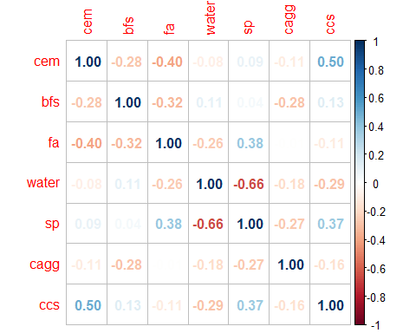

# gam function) to predict the Concrete Compressive Strength  
dataModel1 <- gam(ccs ~ cem + bfs + fa + water + sp + cagg , data=concrete_data)  
summary(dataModel1)

##   
## Family: gaussian   
## Link function: identity   
##   
## Formula:  
## ccs ~ cem + bfs + fa + water + sp + cagg  
##   
## Parametric coefficients:  
## Estimate Std. Error t value Pr(>|t|)   
## (Intercept) 5.326997 10.510518 0.507 0.612387   
## cem 0.108256 0.005214 20.761 < 2e-16 ***  
## bfs 0.079357 0.006193 12.814 < 2e-16 ***  
## fa 0.055928 0.009287 6.022 2.4e-09 ***  
## water -0.103871 0.027796 -3.737 0.000197 ***  
## sp 0.356016 0.110251 3.229 0.001281 **   
## cagg 0.008027 0.006272 1.280 0.200940   
## ---  
## Signif. codes: 0 '***' 0.001 '**' 0.01 '*' 0.05 '.' 0.1 ' ' 1  
##   
##   
## R-sq.(adj) = 0.445 Deviance explained = 44.9%  
## GCV = 155.83 Scale est. = 154.77 n = 1030

# compare the R2 value for a GAM with linear terms as well as smoothed terms  
cat("The corrected R-squared + shows that a sizable portion of the variation is present, and it appears that we have statistical effects for CEM and BFS but not for CAGG.")

## The corrected R-squared + shows that a sizable portion of the variation is present, and it appears that we have statistical effects for CEM and BFS but not for CAGG.

# Use the s() function to apply smoothing using the default bs of tp).  
dataModel2 <- gam(ccs ~ s(cem) + s(bfs) + s(fa) + s(water) + s(sp) + s(cagg) , data=concrete_data)  
summary(dataModel2)

##   
## Family: gaussian   
## Link function: identity   
##   
## Formula:  
## ccs ~ s(cem) + s(bfs) + s(fa) + s(water) + s(sp) + s(cagg)  
##   
## Parametric coefficients:  
## Estimate Std. Error t value Pr(>|t|)   
## (Intercept) 35.8178 0.3566 100.4 <2e-16 ***  
## ---  
## Signif. codes: 0 '***' 0.001 '**' 0.01 '*' 0.05 '.' 0.1 ' ' 1  
##   
## Approximate significance of smooth terms:  
## edf Ref.df F p-value   
## s(cem) 4.464 5.513 69.530 < 2e-16 ***  
## s(bfs) 2.088 2.578 48.091 < 2e-16 ***  
## s(fa) 5.332 6.404 1.784 0.101   
## s(water) 8.567 8.936 13.504 < 2e-16 ***  
## s(sp) 7.133 8.143 5.498 1.22e-06 ***  
## s(cagg) 1.000 1.000 0.018 0.892   
## ---  
## Signif. codes: 0 '***' 0.001 '**' 0.01 '*' 0.05 '.' 0.1 ' ' 1  
##   
## R-sq.(adj) = 0.531 Deviance explained = 54.4%  
## GCV = 134.84 Scale est. = 130.96 n = 1030

cat("We should also remark that this model, with an adjusted R-squared of.531, explains a large portion of the variance in CCS. In summary, it appears that the CEM and CCS are connected.")

## We should also remark that this model, with an adjusted R-squared of.531, explains a large portion of the variance in CCS. In summary, it appears that the CEM and CCS are connected.

# showing the fit as a function of each predictor  
dataModel1.sse <- sum(fitted(dataModel1)-concrete_data$ccs)^2  
dataModel1.ssr <- sum(fitted(dataModel1) -mean(concrete_data$ccs))^2  
dataModel1.sst = dataModel1.sse + dataModel1.ssr  
Rsquared=1-(dataModel1.sse/dataModel1.sst)  
cat(Rsquared)

## 0.4967177

dataModel2.sse <- sum(fitted(dataModel2)-concrete_data$ccs)^2  
dataModel2.ssr <- sum(fitted(dataModel2) -mean(concrete_data$ccs))^2  
dataModel2.sst = dataModel2.sse + dataModel2.ssr  
Rsquared_sm=1-(dataModel2.sse/dataModel2.sst)  
cat(Rsquared_sm)

## 0.5000744

anova(dataModel1, dataModel2, test="Chisq")

## Analysis of Deviance Table  
##   
## Model 1: ccs ~ cem + bfs + fa + water + sp + cagg  
## Model 2: ccs ~ s(cem) + s(bfs) + s(fa) + s(water) + s(sp) + s(cagg)  
## Resid. Df Resid. Dev Df Deviance Pr(>Chi)   
## 1 1023.00 158334   
## 2 996.43 131019 26.574 27315 < 2.2e-16 ***  
## ---  
## Signif. codes: 0 '***' 0.001 '**' 0.01 '*' 0.05 '.' 0.1 ' ' 1

cat("Although we couldn't have known as much already, new statistical evidence suggests that adding in the variables' nonlinear correlations enhances the model.")

## Although we couldn't have known as much already, new statistical evidence suggests that adding in the variables' nonlinear correlations enhances the model.

visreg(dataModel1,'cem')

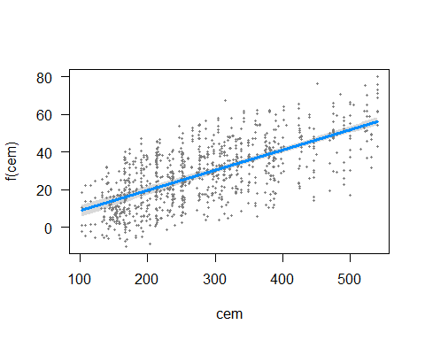

visreg(dataModel2,'cem')

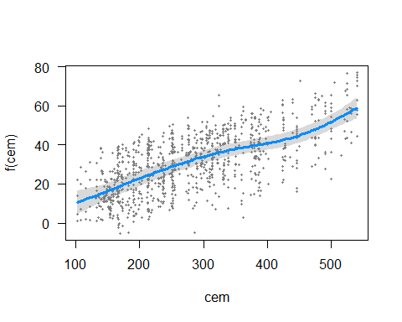

cat("The end result, with all other model variables maintained constant,   
 is a plot showing how the expected value of the CCS changes as a function of x (CEM).   
 It contains the following information: (1) the expected value (blue line),   
 (2) a confidence interval for the expected value (gray band), and   
 (3) partial residuals (dark gray dots).")

## The end result, with all other model variables maintained constant,   
## is a plot showing how the expected value of the CCS changes as a function of x (CEM).   
## It contains the following information: (1) the expected value (blue line),   
## (2) a confidence interval for the expected value (gray band), and   
## (3) partial residuals (dark gray dots).

# Visualizing the feature with the function of their feature  
visreg(dataModel1,'bfs')

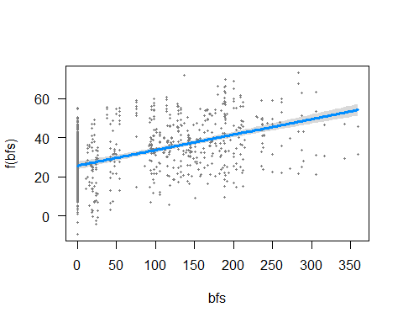

visreg(dataModel2,'bfs')

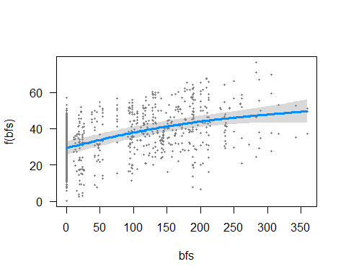

visreg(dataModel1,'fa')

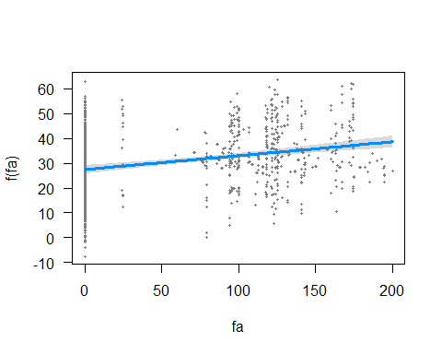

visreg(dataModel2,'fa')

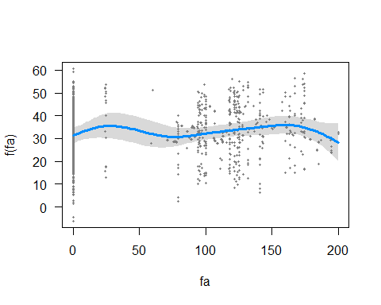

visreg(dataModel1,'water')

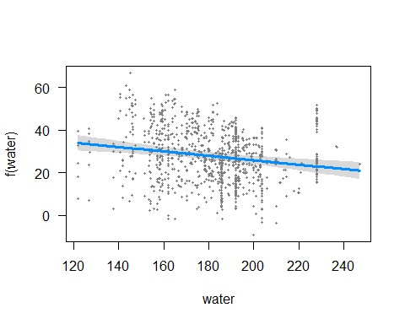

visreg(dataModel2,'water')

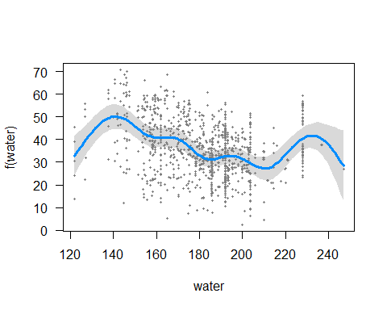

visreg(dataModel1,'sp')

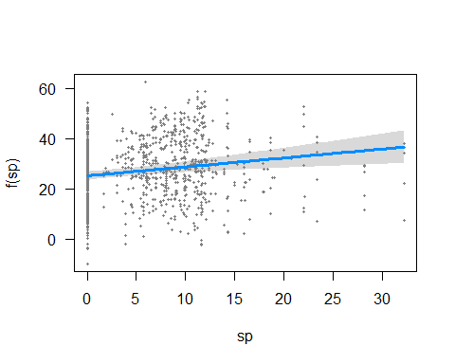

visreg(dataModel2,'sp')

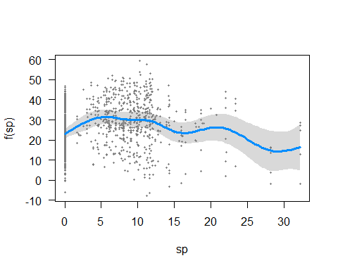

visreg(dataModel1,'cagg')

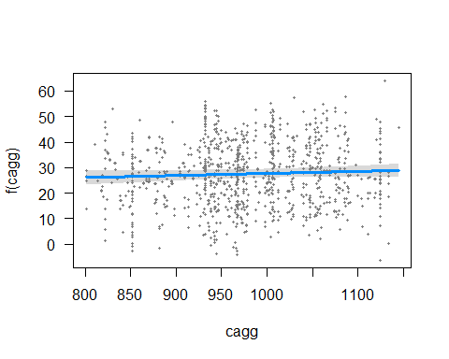

visreg(dataModel2,'cagg')

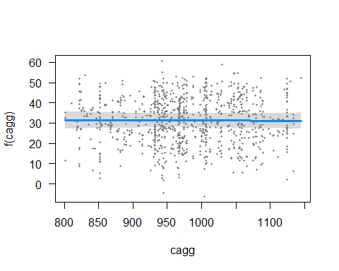

cat("We can see from the CEM graph that the confidence interval has a higher value after adding the smoothing function than the model had without it. Using the smoothing function improves the confidence interval.")

## We can see from the CEM graph that the confidence interval has a higher value after adding the smoothing function than the model had without it. Using the smoothing function improves the confidence interval.